General requirement:

Create a model class store all needed data to render the report.

Fill some sample data to test the report.

Export to excel with predefine format.

Need to finish in 6 days.

Report 01:

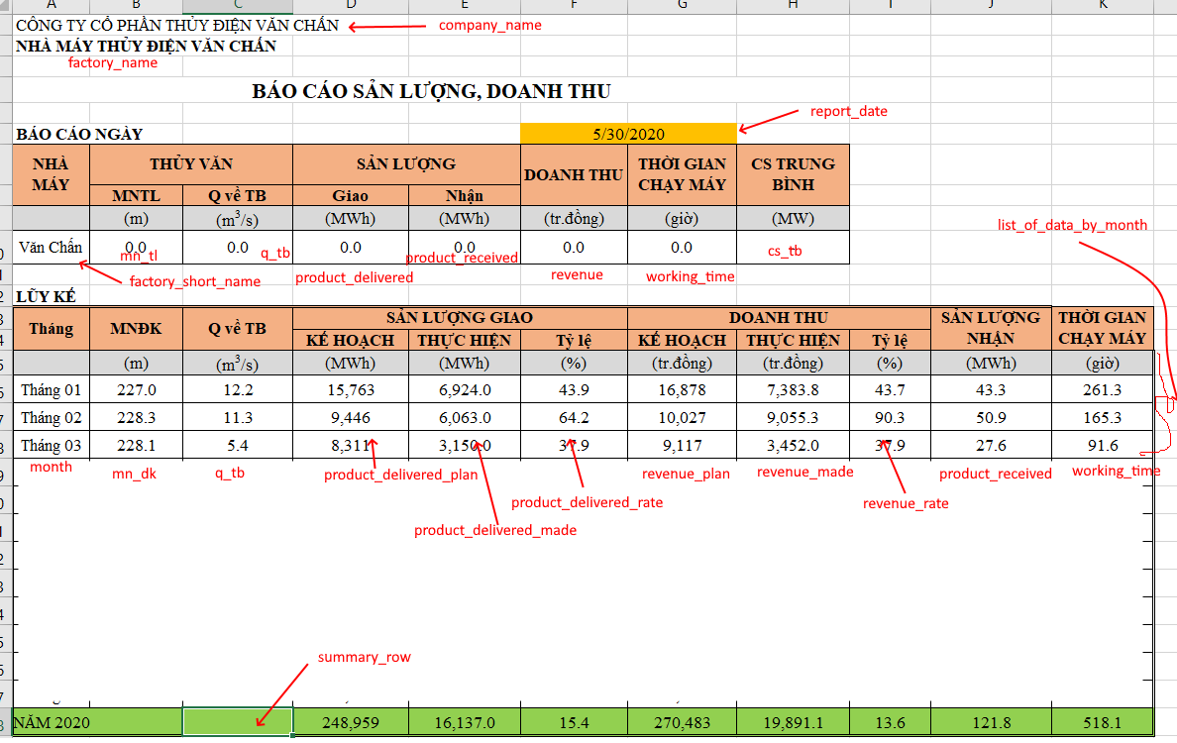

Report 02:

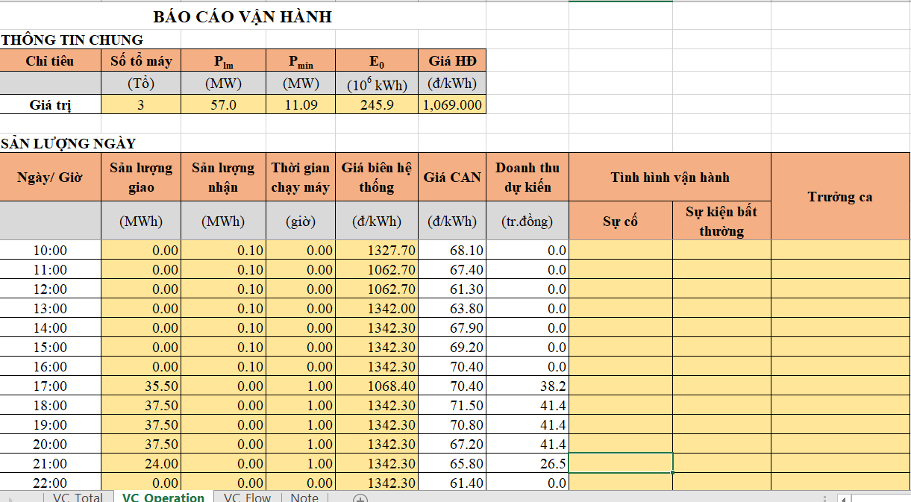

Report 03:

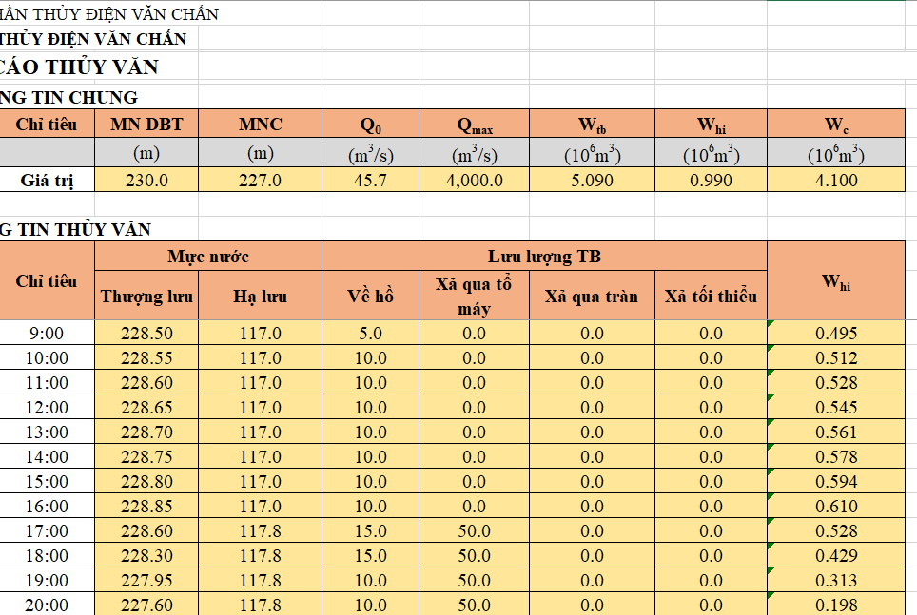

Report 04: Summary report

